In this question, we examine if Medicare beneficiaries older than 65 belonging to different racial groups show distinctions in financial ability. In particular, we would like to compare the financial ability of Non-Hispanic white with that of Non-Hispanic black. We used the ‘ACC_HCDELAY’: ‘Last year ever delay in care due to cost’ as a proxy variable for financial ability indication. For this variable, the value 1 = Yes means the person has delayed care for money reasons. We also filtered out value = R or D for this variable, since these two values mean interviewees are not willing to reveal their status with regards to this variable, and are equivalent to null values.

As a result, we construct the following 2*2 table:



In the columns are races to be investigated, and the rows indicate if the beneficiary delays in care due to cost last year. As we can see from the table, of the two races we investigated, 539 people reported delayed payment for healthcare service last year, indicating they are having financial difficulties. That number, converting to ratio, is 5.96%. Of the people who reported delayed payment, white people account for 14.29%, whereas, black people account for 85.71%, presenting astonishing racial disparity in terms of payment ability for healthcare services.

Moreover, people with financial difficulties account for only 5.98% among the white, whereas, people with the same difficulties account for 9.97% among the black, twice as much as the proportion among white people.

We then conducted a Fisher test, and results of the test is shown below:

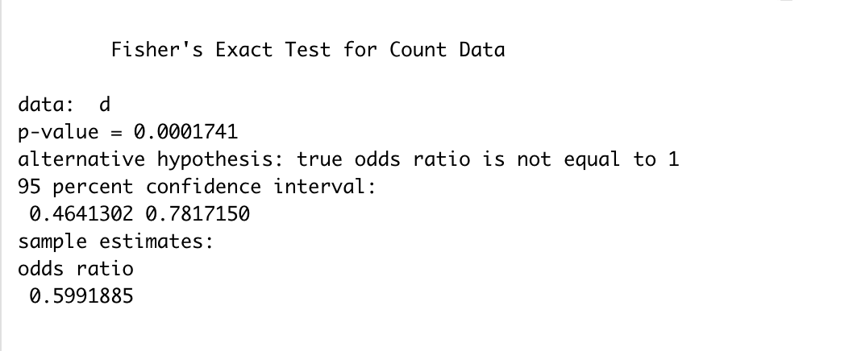

Odds ratio in this case equals to 0.6. It is interpreted as following: the odds of delaying care last year owing to cost if the beneficiary is white is 0.6 compared to if the beneficiary is black with a 95% confidence interval [0.46, 0.78]. The hypothesized odds ratio equals 1. Consequently, p-value equals 0.0001, significantly smaller than 1%. Thus we reach the conclusion that there is racial disparity with regard to financial difficulties and the difference is statistically significant.